Town Hall Overview

# Introduction

In our game, the town hall will serve as the basis for the development of the town from the beginning of the game until the end. The rest of the town will be built around it radially so that players can easily find the town hall once there are lots more buildings around.

The purpose of the town hall is to provide a hub where the player can view their progress, currency and upgrades as well as a place to buy new upgrades and unlock sections of the map to progress further through the game.

## Visuals

Visually, I have an idea where each section of the town has a unique theme, for example the first section might be mushroom themed, the next carrot themed, and then the town hall will be themed as a combination of these themes. We could have it so that once you complete a section, the town hall gets an extension to match the theme of the section you just completed.

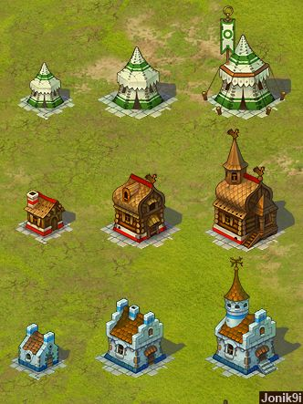

It should also stick out compared to the other buildings, maybe by using size or by using brighter colours in comparison to the town buildings.

# Map Upgrades

# Upgrades

# Stats

# References

Building Upgrades Image: https://i.pinimg.com/736x/da/9c/27/da9c272e172223f80d0ab7ef36f112f5--game-assets-game-ui.jpg